Installing Adobe Acrobat from Creative Cloud
Official URL: https://services.smsu.edu/TDClient/180/Portal/KB/Article/4344/Installing-Adobe-Acrobat-from-Creative-Cloud
Category: Knowledge Base > Information Technology Services > Software and Applications > Installing Adobe Acrobat from Creative Cloud
Tags: AdobeCreativeCloud
_____________________________________________________

Installing Adobe Acrobat from Adobe Creative Cloud
Adobe Acrobat is a subscription based software that allows users to create, edit, manage, print, and share PDF documents. It can be used online as well as downloaded on to your computer and SMSU faculty and staff have this application -as well as others- available to them through the Adobe Creative Cloud suite already paid for by the university. These are referred to as "Named User Accounts" meaning the license was applied to your SMSU work email and not intended to be shared with a group.

How to install Adobe Acrobat and additional applications from Creative Cloud
- Click on the Adobe Creative Cloud Icon as shown below on your desktop or search for it in the search bar
Click on the Adobe Creative Cloud Icon as shown below on your desktop or search for it in the search bar
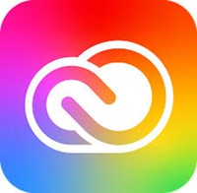
Figure 1: Adobe Creative Cloud desktop application icon displayed on a computer desktop or in the Windows search results.
- If not signed in yet, go ahead and sign you with your starid@minnstate.edu and starid password. It will then open up the Creative Cloud Desktop that will display all the Adobe applications as shown below
If not signed in yet, go ahead and sign you with your starid@minnstate.edu and starid password. It will then open up the Creative Cloud Desktop that will display all the Adobe applications as shown below
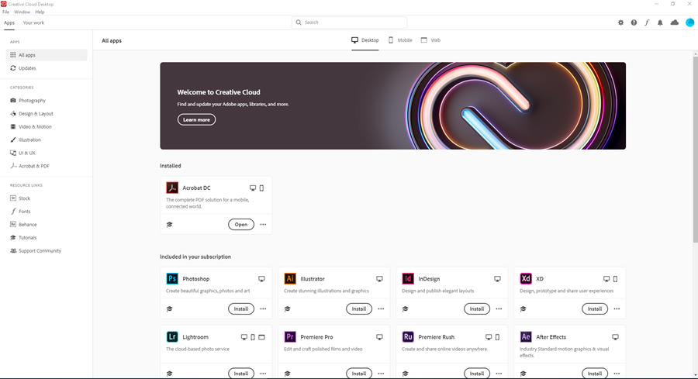
Figure 2: Adobe Creative Cloud desktop application showing a list of available Adobe apps, including Acrobat DC.
- Select Acrobat DC to download Adobe Acrobat and click on the install button.
NOTE: You may also install any other applications within the Creative Cloud suite that you would like to have.
- After installing Adobe Acrobat DC click on the Adobe Acrobat DC icon to launch the program.
After installing Adobe Acrobat DC click on the Adobe Acrobat DC icon to launch the program.
- You will get the sign in window, click on Sign In Now
You will get the sign in window, click on Sign In Now
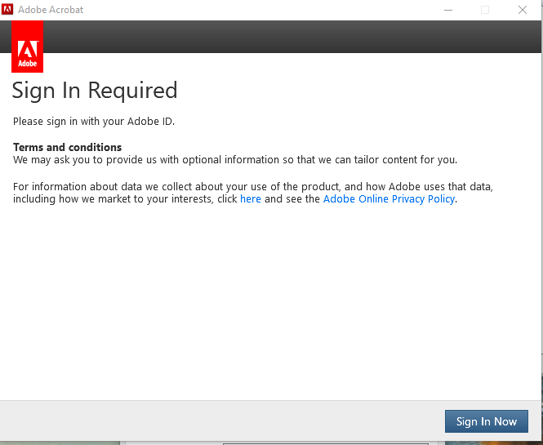
Figure 3: Adobe Acrobat sign-in screen with a ‘Sign In Now’ button prompting the user to authenticate.
- When prompted with the screen below Sign in using your starid@minnstate.edu and after some processing then click continue in the Thank You screen and you will have access to the licensed product.
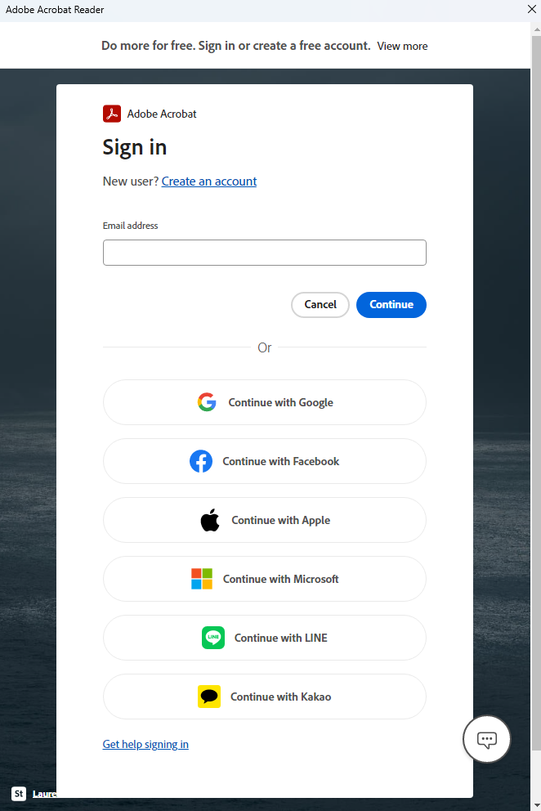
Figure 4: Login screen prompting the user to sign in with their StarID email address associated with the university.
Accessibility Review & Update Log:
- [x] Content accuracy and link integrity verified
- [x] High-contrast visual hierarchy implemented (Inter and Calibri)
- [x] Image alt-text captions verified (all screenshots captioned)
- [x] PDF attachments scraped and fully inlined directly inside the document
- [x] Outline headers and standard list sequences optimized for screen readers

